Weekly Research Report Studio 6

Student name : Zihan Liu

Report date : 26/4/2024

What did you do this week?

*Outline briefly what you did this week and what you achieved.*

*In week 1, I browsed a lot of materials to be able to fully prepare the project coding workflow and knowledge.*

*I made a user management framework in front-end applications*

*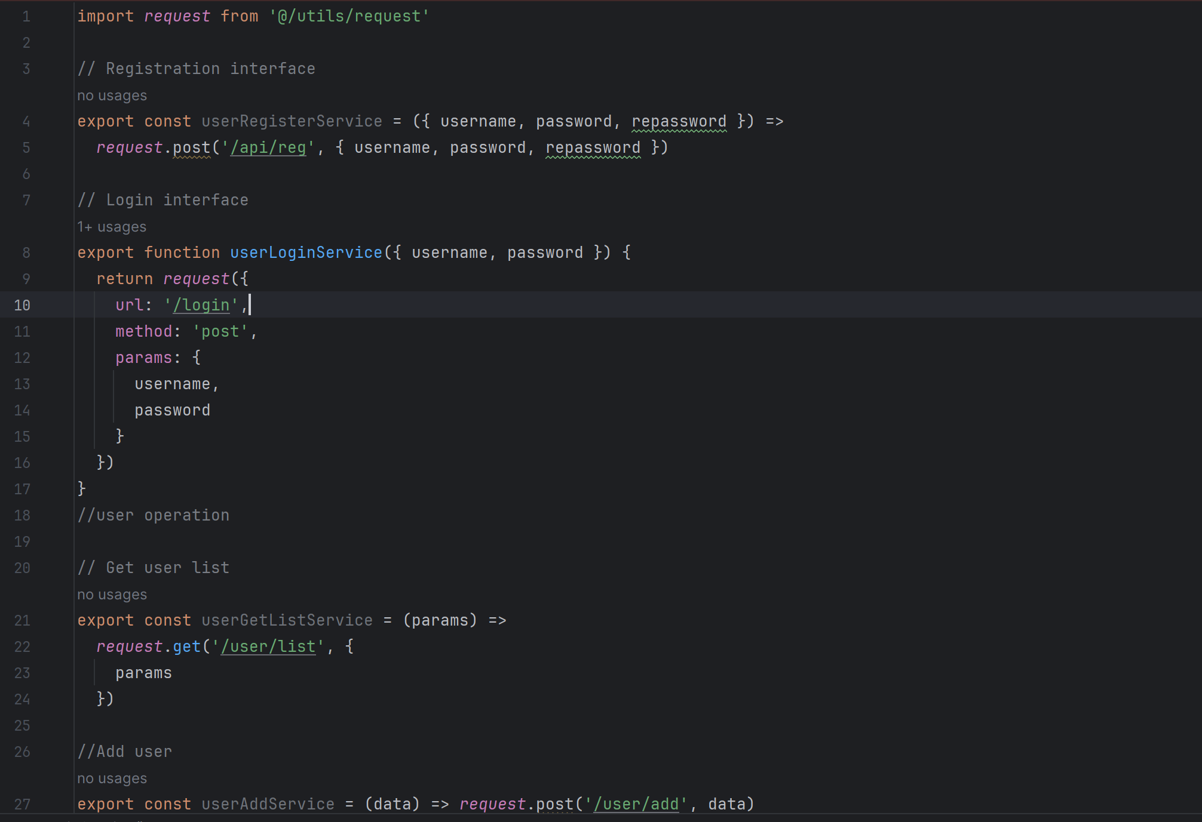*

I also used Pinia to build the user state management framework and used the Composition API in Vue 3

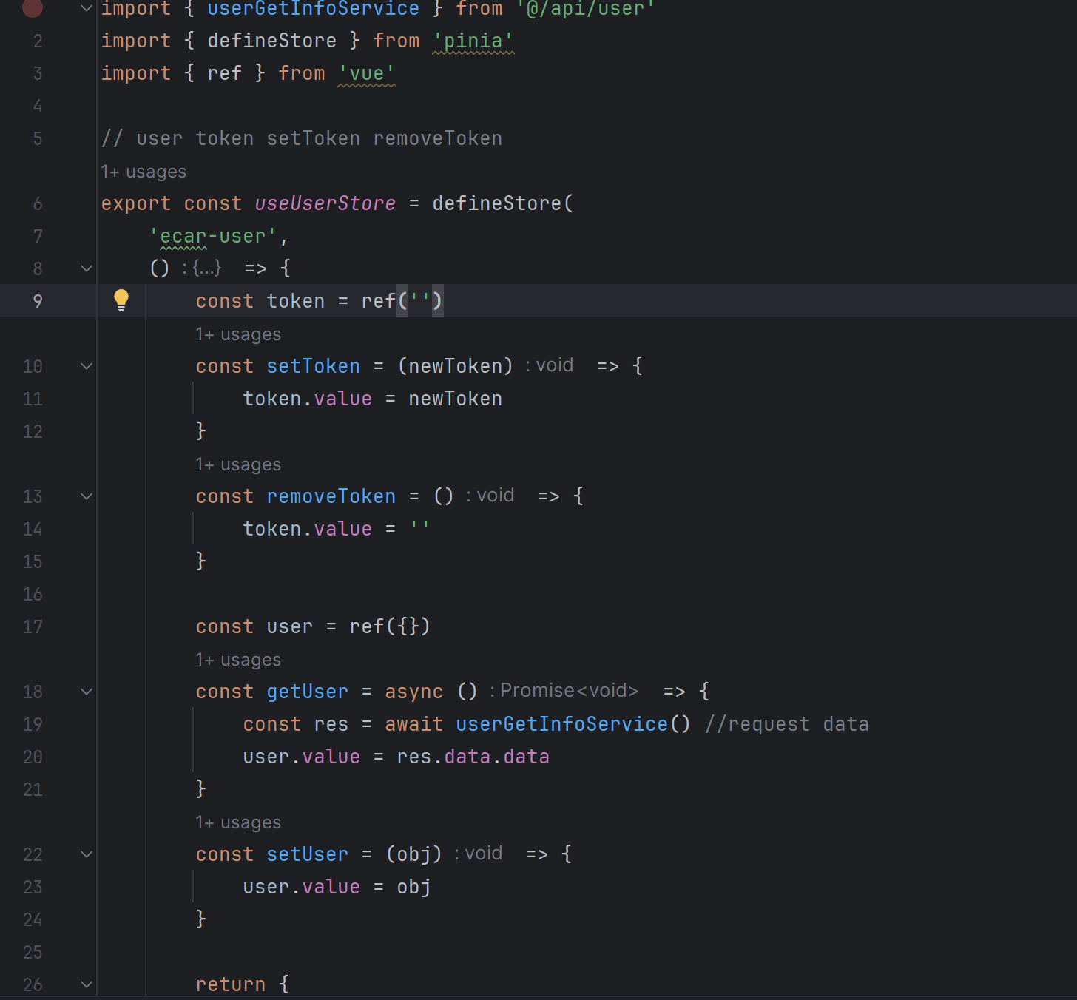

What are you planning to do next week?

*Describe what you plan to do next week and what you want to achieve.*

*Make the login and register function work and interact with MySQL database*

Do you need help with anything?

*What can your supervisor help you with? Make a list of things we can work on together.*

Any advises of the workflow, should I do the login functions at first? Or should I finalized all the front end pages first.